Book Id:-111,222,333,444,555

**Fetch All Book:-**

@GetMapping("/books")

localhost:4040/books

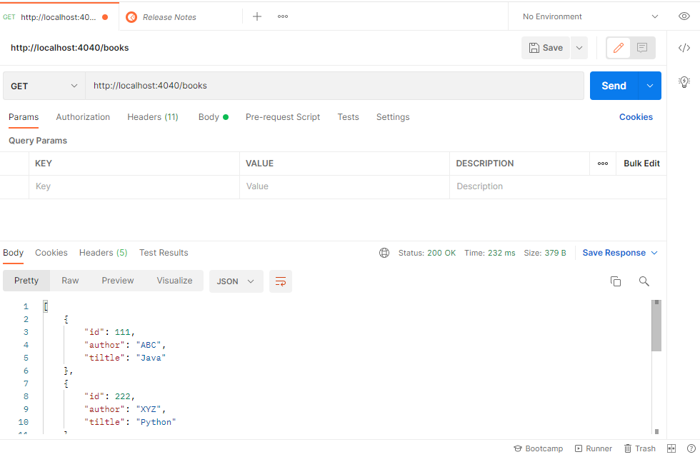

**Fetch One Book:-**

@GetMapping("/books/{id}")

http://localhost:4040/books/444

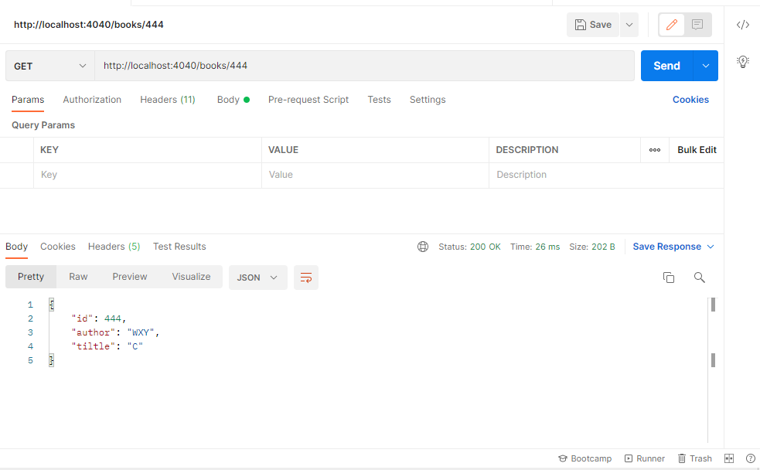

**Delete One Book By ID:-**

@DeleteMapping("/books/{bid}")

<http://localhost:4040/books/222>

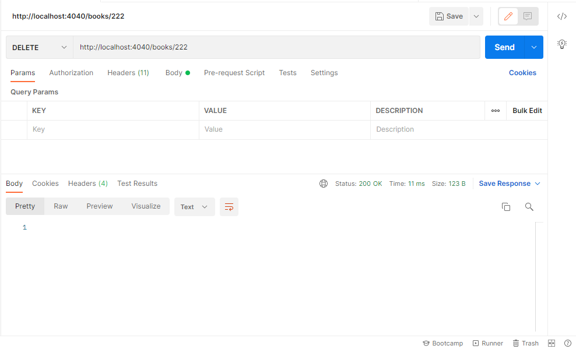

**Put One Book By ID/Update Book by ID:-**

select PUT->raw->json

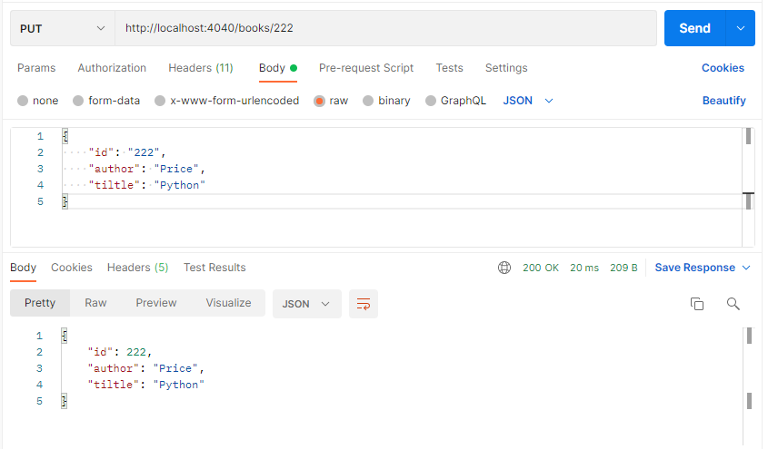

**Add Book:-**

@PutMapping("/books/{bid}")

http://localhost:4040/books/222

{

"id": "222",

"author": "Price",

"tiltle": "Python"

}

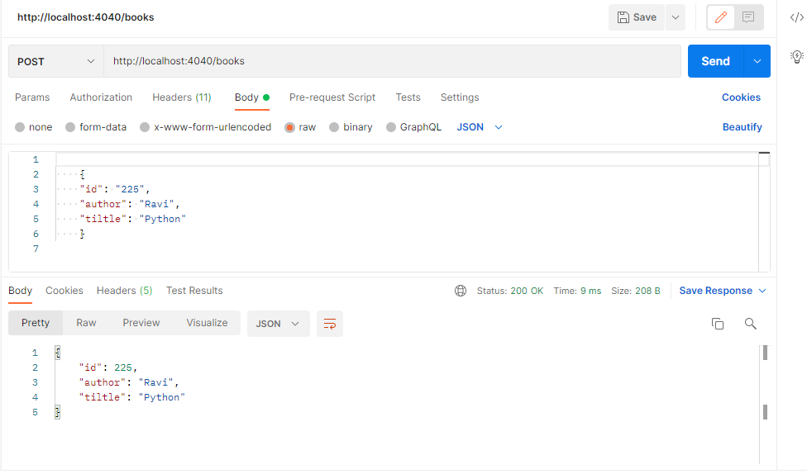

@PostMapping("/books")

{

"id": "555",

"author": "Price",

"tiltle": "Python"

}